Jar file to war how to change ;
First we need jar file , jara file is by deflut we have jar file,
Cd ems
Ls
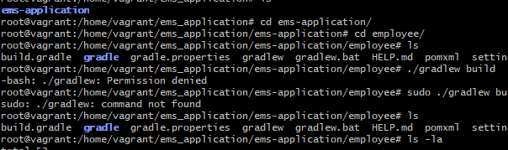
Cd employe
Ls
Remove build
Sudo rm -rf build
Check to the permission to gradle
Then change permission,
Sudo chmod +x gradle
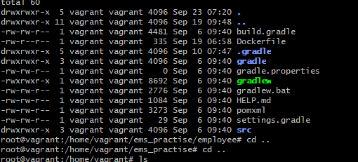
Run to the build
How to run build,
./gradle
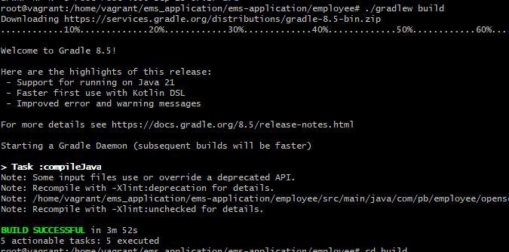
Check build file,
Cd build/libe/
Ls
Check the jar file



